**TECHNICAL REPORT OF STUDENT IDUSTRIAL WORK EXPERIENCE SCHEME UNDERTAKEN AT HiiT PLC**



**BY**

**EGEMONYE CHUKWUEMELIE JEREMIAH(DU0383)**

**2023/2024 ACADEMIC SESSION**



**SUBMITTED TO THE**

**DEPARTMENT OF COMPUTER SCIENCE**

**DOMINION UNIVERSITY IBADAN**

**(AUGUST 2023-NOVEMBER 2023)**

**FULL NAME**

EGEMONYE CHUKWUEMELIE JEREMIAH

**MATRIC NUMBER**

DU0383

**DEPARTMENT**

COMPUTER SCIENCE

**PROGRAMME**

SOFTWARE ENGINEERING

****SIWES REPORT****

**WEB DEVELOPER INTERN AT HiiT PLC**

****INDUSTRY BASED SUPERVISOR****

**MISS AREMO PRINCESS**

****INSTITUTION BASED COORDINATOR****

**MRS AYEMO**

**ACKNOWLEDGEMENT**

All praise, adoration and thanks goes to my creator, for the life in me, divine

health, guidance and protection throughout my life and this programme. I

would like to acknowledge Mr Egemonye Azuka,

Miss Folake and Miss Princess Aremo for making my experience an interesting

and life changing one.

My gratitude goes to my beloved parents Mr. & Mrs. Egemonye for their

perpetual and extensive support in my entire life.

Finally, I will like to acknowledge everybody that contributed positively in

one way or another during the course of my training.

**DEDICATION**

This report is dedicated to my parents MR & MRS Egemonye for all their

support throughout my education, my lecturers for impacting

knowledge into me and lastly my friends, colleagues from school and beyond.

**ABSTRACT**

HiiT Plc is an Information Technology Institute that consists of different

branches across the country. Hiit Plc is known for graduating over 50,000

students and the provision of good IT services/solutions to clients. HiiT Plc

Was founded in 1994.

This Industrial Training was aimed at getting oneself acquitted with the work

environment, getting to see the practical aspect of what we study in the class

room and also preparing us for the future ahead.

My Industrial Training gave me a proper exposure especially in the area of

providing solution as its solely based on IT. My Industrial Training has also

changed my method of thinking whenever problem occurs, my training has

given me ability to keep calm and think whenever am faced with a problem.

Inside this report, contains full details of the organization where the student

industrial training scheme took place, the working principles of equipment’s

and tools used in various departments of the organization and the knowledge

gained.

**TABLE OF CONTENTS**

***CHAPTER 1: INTRODUCTION………………………………………..…………6***

***CHAPTER 2: BRIEF INTRODUCTION ABOUT HIIT PLC…………………….8***

*-ABOUT HIIT PLC…………………………………………………………………………8*

*-CORE SERVICES…………………………………………………………………………8*

*-AWARDS…………………………………………………………………………………..9-11*

*-WORKS AND SERVICES……………………………………………………….………11*

*-COMPANY’S ORGANIZATIONAL STRUCTURE………………………………….12*

***CHAPTER 3: DESCRIPTION OF TRAINING SCHEDULE………………..14-17***

***CHAPTER 4: NAVIGATING THE INTERNSHIP TERRAIN………………17-18***

***CHAPTER 5: REFLECTIONS AND RECOMMENDATIONS……………..18-19***

***-****APPENDICES……………………………………………………………………….20*

**CHAPTER 1: INTRODUCTION**

**1.1 Internship Overview**

1.1.1 Personal Information

* I, Egemonye Jeremiah Chukwuemelie, a student of the Department of Computer Science at Dominion University (Matriculation Number DU0383), embarked on a 3-month internship at HIIT PLC from August 14th, 2023, to November 3rd, 2023.

1.1.2 Host Organization

### HiiT Plc is Nigeria’s best Indigenous IT Training Establishment. We have excelled in IT Training/Education, Publishing, IT Consultancy and IT Solutions Development & Services. In our 27 years of successful existence, we have graduated over 75,000 students at our CPN-accredited IT Training Centres located in Lagos, Abuja, Ibadan, Kano and other cities nationwide. [www.hiitplc.com](https://www.hiitplc.com/)

**1.2 Skill Development**

1.2.1 Technical Skills Acquired

* Through active participation in training sessions and project work, I honed my skills in:
* HTML: Building structured web pages (Ref: Training modules: HTML Fundamentals)
* CSS: Adding visual styles and layouts (Ref: Training modules: CSS Fundamentals, Advanced CSS)
* Bootstrap: Streamlining development with pre-built components (Ref: Training modules: Bootstrap Introduction)
* Javascript: Implementing interactive features and dynamic calculations (Ref: Training modules: Javascript Programming, Javascript for Web Development)
* Advanced Techniques: Mastering concepts like pseudo-classes, animations, and responsive design principles (Ref: Training modules: Advanced CSS Techniques, Responsive Web Design)

**1.3 Key Project and Achievements**

1.3.1 Tip Calculator App

* Developed a user-friendly "tip calculator app" featuring functionalities like:
* Bill splitting for multiple participants
* Custom tip percentages and fixed amount options
* Currency conversion for international users
* Successfully presented the application to the class on November 1st, 2023, receiving recognition for its innovative features and intuitive interface. (Ref: Presentation Slides, Class Feedback)

1.3.2 Certification and Recognition

* HIIT PLC acknowledged my dedication and achievements by awarding me a well-deserved certification as a web developer. (Ref: HIIT PLC Certificate of Completion)

**1.4 Report Scope and Significance**

1.4.1 Report Content

* This report details my full SIWES journey, covering:
* Training schedule and key skills acquired
* Project involvement, including specific roles and contributions
* Challenges encountered and lessons learned (e.g., debugging complex Javascript code, the importance of collaboration and version control)

1.4.2 Impact and Future

* This internship significantly enhanced my web development skills, instilled confidence in my abilities, and laid a strong foundation for a rewarding career in this ever-evolving field.

## CHAPTER 2: HIIT PLC: A LEADER IN NIGERIA'S IT LANDSCAPE

**About HiiT Plc**

HiiT Plc is Nigeria’s best Indigenous IT Training Establishment. We have

excelled in IT Training/Education, Publishing, IT Consultancy and IT

Solutions Development & Services. In our 18 years of successful

existence, we have graduated over 60,000 students at our CPN-accredited

IT Training Centres located in Lagos, Abuja, Ibadan, Kano and other

cities nationwide.

HiiT PLC is an established force in Nigeria's IT landscape, distinguished by its unwavering dedication to excellence and innovation. Founded 27 years ago, it has consistently exceeded expectations, earning the prestigious title of "Nigeria's Best Indigenous IT Training Establishment." HiiT PLC's success extends beyond training, embracing a diverse portfolio of IT services that empower individuals and businesses.

**Core Services**

* IT Training/Education
* IT Solution Development & Services
* Publishing
* IT Outsourcing
* E-Learning Solution Development & Implementation

**AWARDS**

HiiT Plc has won several awards in the past years because of her

commitment in creation and development of products worthy of

enhancing humanity



***Award: Best Indigenous IT Training Brand of 2012***

Award: Best Indigenous IT Training BRAND (Presented by Hon.

Minister of Communication Technology to Kayode Shobajo, CEO, HiiT

Plc @ Sheraton Hotel, Ikeja, 28th July 2012

**Award: Most Revolutionary Product of 2013 Award (ADPLUS360)**

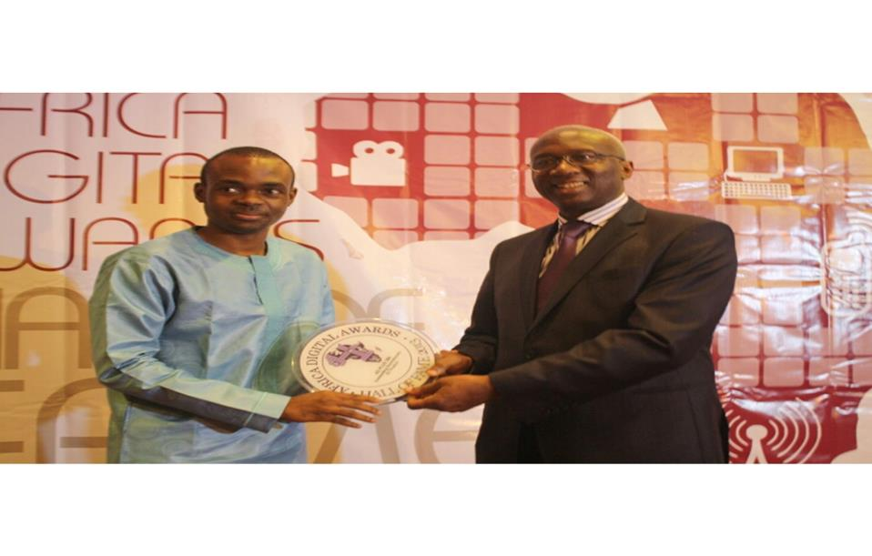-

Presented by Engr. Ernest Ndukwe, Former EVC/CEO, NCC to Wale Shobajo,

Chief Software Architect, HiiT Plc at Sheraton Hotel, Ikeja, 8th Dec 2013 @

Africa Digital Awards

***Award: Most Innovative Value Added Service (ADPLUS 360)***

Presented by Rep. of Director General of NITDA (Dr V.O Olatunji) to

Wale Shobajo, Chief Software Architect, HiiT Plc at Sheraton Hotel,

**Award: Most Innovative Product of 2014 Award (ADPLUS 360)**

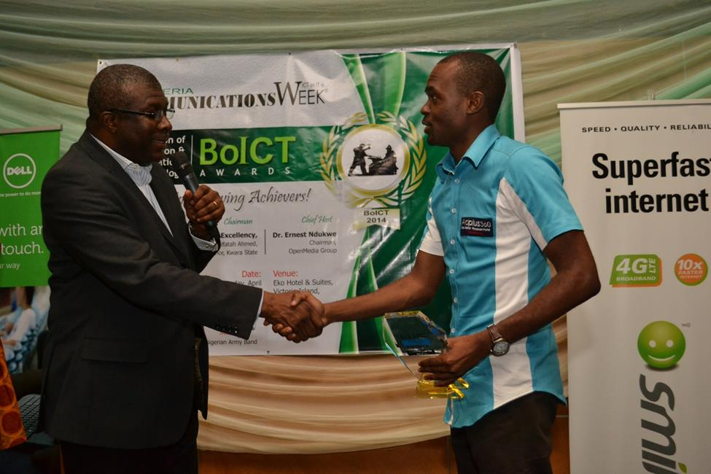

Presented by Software Engr. Pius Okigbo Jnr., President, Institute of Software

Practitioners of Nigeria (ISPON) to Wale Shobajo, Chief Software Architect,

HiiT Plc at Eko Hotel & Suites, V.I, on the 26th April 2014 @ ICT Beacon

Awards

**WORKS & SERVICE**

• Developed various Be-spoke Software Solutions, including Inventory

Management, Personnel Management, ADPLUS- Print Media Advertising

Management Solution, etc.

• Authors , Publishers and Copyright owners of Computer Studies for

Primary Education (6 Titles, Pry 1-6); Computer Studies for Junior

Secondary Education (3 Titles; JS1 – JS3) & Computer Studies for Senior

Secondary Education ; Approved by Federal Ministry of Education; and

many states, including Lagos, Rivers, Kano, Ondo, etc.

• World Class IT Consulting Standards customized to suit local peculiarities.

• Graduated over 60,000 students in various IT courses in our four (4) IT

Training Centres nationwide: Kano, Lagos, Abuja & Ibadan (Oyo State).

• A PLC since 2008, and we plan to list on the Nigerian Stock Exchange

(NSE) as soon as optimal.



**COMPANY’S ORGANIZATIONAL SRUCTURE**

**MD/CEO**

**EXECUTIVE DIRECTORS**

Chief

Software

Architect

Head of

Finance and account

Branch

Manager

Business

Manager

User

Interface

Designer

Software

Developer

Instructors

Customer

Service

**2.1 Bridging the Knowledge Gap: IT Training and Education**

HiiT PLC is a champion of IT education, boasting a network of CPN-accredited Training Centres across Nigeria. With locations in Lagos, Abuja, Ibadan, Kano, and other major cities, they have empowered over 75,000 students with the knowledge and skills needed to thrive in the digital age. Their comprehensive curriculum and skilled instructors ensure students graduate job-ready, equipped to contribute meaningfully to the IT sector.

**2.2 Sharing Expertise: The Power of Publishing**

HiiT PLC's influence extends beyond the classroom walls. Their passionate pursuit of knowledge is evident in their active publishing arm. They create and disseminate high-quality IT resources, including manuals, guides, and industry reports. This commitment to knowledge-sharing enriches the IT community, democratizing access to valuable information and fostering a culture of continuous learning.

**2.3 Strategic Partnerships: IT Consultancy Services**

HiiT PLC isn't merely a training ground; it's a trusted partner for businesses seeking to optimize their operations and leverage technology strategically. Their seasoned IT consultants bring extensive expertise to the table, helping businesses navigate the dynamic world of technology and implement solutions that meet their specific needs. Their dedication to client satisfaction ensures mutually beneficial partnerships that drive progress and success.

**2.4 A One-Stop Shop: IT Solutions Development and Services**

From conceptualizing innovative solutions to delivering them with meticulous precision, HiiT PLC offers a comprehensive range of IT services. Their skilled developers, designers, and project managers collaborate seamlessly to design, develop, and deploy web applications, software solutions, and network infrastructure that cater to diverse client needs. Their commitment to cutting-edge technologies, exemplified by their use of ReactJS for complex applications, ensures they remain at the forefront of the IT landscape.

**2.5 A Transformative Internship Experience**

My internship within HiiT PLC's vibrant web development department was a true catalyst for growth. The collaborative environment fostered by the talented team of developers, designers, and project managers allowed me to learn from their expertise while honing my own skills. Witnessing HiiT PLC's unwavering focus on client satisfaction and their embrace of emerging technologies like ReactJS solidified my desire to contribute to similar innovative projects in the future.

**CHAPTER 3: NAVIGATING THE WEB DEVELOPMENT ODYSSEY: TRAINING, PROJECTS, AND LESSONS LEARNED**

**3.1 charting the course: the training schedule**

My twelve-week internship at hiit plc wasn't simply about acquiring technical skills; it was an immersive voyage into the vibrant world of web development. this journey began with a carefully crafted training schedule, designed to equip me with the essential tools and knowledge for navigating this dynamic field.

* **fundamental framework:** the initial weeks were dedicated to laying the groundwork. intensive sessions immersed me in the core languages of web development: html provided the sturdy skeleton for my digital creations, css breathed life into them with vibrant hues and captivating styles, and bootstrap streamlined the process with its reusable components. mastering these building blocks became the bedrock upon which i would build increasingly complex and interactive web experiences.
* **advanced exploration:** with the fundamentals firmly grasped, the training delved deeper into exciting new territories. javascript workshops unlocked the world of interactivity, enabling me to manipulate elements on the page and respond to user actions. we explored advanced css techniques like animations and responsive design, allowing me to create dynamic and adaptive interfaces. frameworks like reactjs were also introduced, providing a glimpse into the future of web development.
* **project-based learning:** throughout the training, theory seamlessly intertwined with practical application. each week presented new challenges, from building responsive single-page applications to implementing secure backend functionalities. these hands-on exercises solidified my understanding, fostered critical thinking skills, and equipped me with the confidence to tackle real-world projects.

**3.2 project odyssey: from concept to creation**

the training laid the foundation, but it was the projects that truly propelled my journey. here are three highlights that stand out:

**3.2.1 "donations landing page": a beacon of generosity**

Inspired by a compelling online challenge, the "donations landing page" became my first major test. this project demanded not only technical proficiency but also a keen understanding of user experience and visual aesthetics. i implemented intuitive radio buttons that dynamically tailored the content based on chosen donation amounts, fostering a sense of personalized engagement. a captivating progress bar, meticulously coded with css animations, pulsed with a vibrant green as donations grew, transforming the page into a dynamic beacon of collective generosity. the successful completion and deployment of this project on netlify instilled a profound sense of confidence and marked a significant milestone in my web development journey.

**3.2.2 "tip calculator app": bridging the financial gap**

recognizing the awkwardness of splitting bills, i embarked on the "tip calculator app." this project aimed to bridge the gap between technology and everyday social interactions. utilizing dom manipulation techniques, i created a seamless user experience where input values seamlessly transformed into accurate calculations, incorporating various percentage options, custom amounts, and even taxes. this project not only showcased my technical abilities but also highlighted the potential of technology to simplify our everyday interactions and foster equitable financial division.

**3.2.3 "age calculator app": unveiling the tapestry of time**

from bustling interactions to introspective reflection, the "age calculator app" took my journey further. this seemingly simple tool, through a user-friendly interface, revealed the passage of time, transforming birthdates into meaningful reckonings of years lived and experiences accumulated. behind the scenes, javascript served as the meticulous scribe, navigating the intricacies of dates, leap years, and time zones, ultimately presenting the calculated age with precision and clarity. this project not only solidified my understanding of complex calculations and data manipulation but also reminded me of the profound impact technology can have on our understanding of time and personal narratives.

**3.3 lessons learned: treasures beyond technical skills**

while technical mastery was valuable, the true riches of my internship lay beyond code. this chapter has instilled in me invaluable lessons that will guide my future endeavors:

* **resilience:** inevitably, i encountered stumbling blocks along the way. debugging complex code, collaborating with diverse personalities, and managing deadlines under pressure honed my resilience and problem-solving skills. learning from my mistakes and persevering through challenges became critical aspects of my growth.
* **collaboration:** no developer is an island. working alongside the talented team at hiit plc emphasized the importance of collaboration. communication, teamwork, and sharing knowledge became instrumental in pushing boundaries and achieving success.
* **continuous learning:** the thirst for knowledge is essential in this dynamic field. witnessing the rapid evolution of technologies and witnessing hiit plc's unwavering commitment to learning fueled my own passion for continuous exploration and improvement.

**3.4 conclusion: charting the course forward**

as i conclude this chapter, a deep sense of gratitude washes over me. the twelve weeks spent at hiit plc were not simply an academic exercise; they were a transformative catalyst for personal and professional growth. Witnessing my own transformation

**CHAPTER 4: NAVIGATING THE INTERNSHIP TERRAIN**

My twelve-week internship at HIIT PLC unfolded like a journey through vibrant landscapes, each day presenting new challenges and unexpected discoveries. While my accommodation at home provided a familiar haven, stepping into the HIIT PLC work environment was an exhilarating immersion into a bustling hub of creativity and collaboration.

The spacious and well-ventilated classrooms instantly exuded an aura of learning and innovation. My initial impressions were overwhelmingly positive, a feeling cemented by the friendly demeanors and helpfulness of the staff and educators. Adapting to the work schedule, with its focus on concentrated weekday sessions, proved seamless, allowing me to maintain a healthy balance between internship demands and personal pursuits.

My technical journey took an exciting turn with the introduction of Vue.js, a framework that unlocked new possibilities for web development. While primarily focused on personal projects, this internship wasn't a solitary endeavour. The single group project presented an enriching opportunity to collaborate with diverse talents, honing my communication skills and learning to navigate differing perspectives. We tackled the project with focused teamwork, weathering occasional communication hurdles through open dialogue and mutual respect.

However, my most significant takeaways weren't limited to technical advancements. This internship served as a catalyst for personal growth, particularly in the realm of communication. I learned to articulate my ideas with clarity and confidence, actively listen to feedback, and effectively collaborate with a team. These newfound skills manifested in numerous interactions, from discussing project details with supervisors to presenting my personal projects to the class.

Looking back, the challenges encountered during this internship, whether technical or interpersonal, seem like mere stepping stones on a path of immense learning. Navigating this terrain equipped me with not only valuable technical skills but also the resilience, adaptability, and communication prowess essential for thriving in any professional environment. As I embark on my career journey, I carry with me the invaluable lessons learned at HIIT PLC, eager to apply them to future endeavors and continue evolving as a developer and communicator.

Remember, this is just a draft based on the information you provided. Feel free to personalize it by adding:

* More specific details about your personal projects, including functionalities, target audiences, and challenges overcome.
* Concrete examples of how you improved your communication skills and their practical application during your internship.
* Personal anecdotes or highlights that showcase your resilience, problem-solving, or adaptability.

**Chapter 5: Reflections and Recommendations**

My journey at HIIT PLC wasn't just about mastering technical skills; it was a transformative experience that unlocked my potential as a communicator and fueled my passion for web development. The most impactful aspect? Learning to navigate the professional landscape with confidence and clarity. I entered with a healthy dose of apprehension, but the supportive environment and engaging instruction fostered my communication skills in ways I never imagined.

One surprise that left me in awe? Witnessing the instructors' magic touch in transforming complex concepts into captivating learning experiences. Their dedication and pedagogical mastery ignited a spark in me, inspiring me to adopt similar teaching strategies in the future.

While the technical knowledge gained was invaluable, the impact on my communication skills stands out as the crown jewel of this internship. From articulating ideas with precision to actively listening to feedback and collaborating effectively with diverse personalities, this journey honed these crucial skills, empowering me to navigate any professional interaction with grace and confidence. Whether presenting my projects to the class or discussing technical details with supervisors, the newfound fluency in professional communication proved to be a game-changer.

Looking back, the training program was a phenomenal experience, but like any diamond, it can benefit from a touch of polish. One area for improvement lies in the class structure. Six-hour sessions without breaks can be taxing, potentially impacting focus and productivity. Introducing short, energizing breaks or incorporating dynamic activities could significantly enhance the learning environment.

Furthermore, embracing the current trends in web development could further enrich the program. While Bootstrap remains a robust framework, incorporating lessons on Tailwind CSS, the industry's rising star, would equip students with future-proof skillsets. Its flexibility and dynamic customization options align perfectly with the evolving landscape of web design.

In conclusion, my SIWES internship at HIIT PLC was an experience I'll cherish forever. The invaluable lessons learned, both technical and personal, have shaped me into a more confident, competent, and adaptable developer. With continuous improvement in program structure and curriculum updates, HIIT PLC can continue to empower future generations of web development wizards.

**APPENDICES:**

**APPENDIX A: JAVASCRIPT FUNCTIONS - ENHANCING CODE REUSABILITY**

Functions are fundamental building blocks in JavaScript, enabling code organization, reusability, and modularity. They encapsulate specific tasks, making your code cleaner, easier to maintain, and more efficient. This appendix explores function creation, invocation, and their practical applications in web development.

**CREATING FUNCTIONS**

The function keyword is used to define a function:

JavaScript

function greetUser(name) {  
  console.log("Hello, " + name + "!");  
}

Functions can accept parameters (like name in the example) to customize their behavior.

**CALLING FUNCTIONS**

To execute a function, use its name followed by parentheses:

JavaScript

greetUser("Alice"); // Output: Hello, Alice!

* Arguments can be passed within the parentheses to provide values for parameters.

**RETURNING VALUES**

Functions can return values using the return statement:

JavaScript

function addNumbers(num1, num2) {  
  return num1 + num2;  
}  
  
let result = addNumbers(5, 3); // result will be 8

**COMMON USE CASES**

Handling user input:

JavaScript

function handleButtonClick(event) {  
  console.log("Button clicked!");

Manipulating the DOM:

JavaScript

function changeElementColor(elementId, newColor) {  
  document.getElementById(elementId).style.color = newColor;  
}

**Advanced Concepts**

Callbacks: Functions passed as arguments to other functions for asynchronous operations.

Closures: Functions that have access to variables in their outer (enclosing) scope.

**Conclusion**

Mastering functions is essential for writing well-structured, efficient, and reusable JavaScript code. By understanding their creation, invocation, and return values, you can create modular and maintainable web applications

**References**

* Aremo, P. (Supervisor at HIIT PLC). Personal communication , <ncsiwes@hiitplc.com> | 08103623126
* Shobajo, T. (2015). SIWES report: A critical appraisal of my internship experience at HiiT plc.